Experiment 5
System Information Commands
Aim
To execute uptime, date, and mv commands.
Theory
uptime Command
Shows system running time.
uptime
date Command
Displays current date and time.
date
mv Command
Moves or renames files.
mv file1.txt file2.txt
Procedure
- Check system uptime.
- Display current date.
- Rename a file using mv.

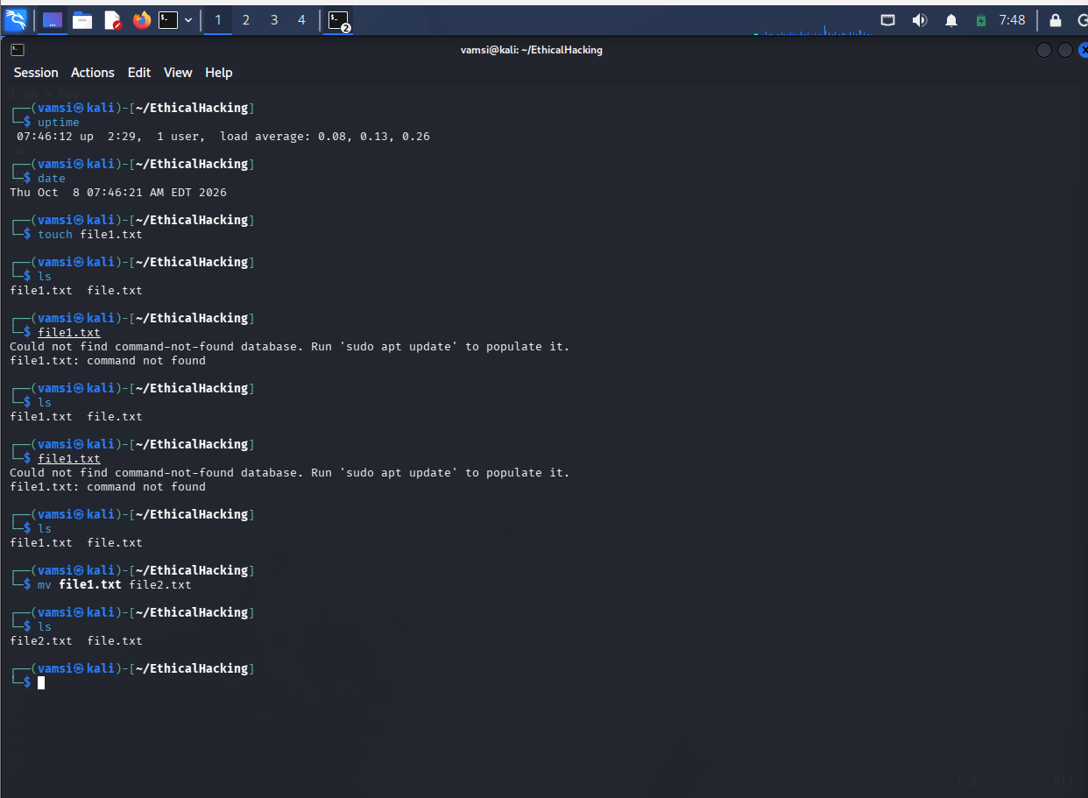
Result
Successfully executed uptime, date, and mv commands.

